**Enhancing Predictive Maintenance for Turbofan Engines Using LSTM Networks and Real-Time Sensor Data**

**Tangxu Ji**

**Background and Motivation**

**Gap or Problem**

Predictive maintenance leveraging advanced machine learning (ML) algorithms is essential in enhancing operational safety and efficiency in industries such as aerospace and automotive (Zhao et al. 2023). However, existing models often struggle to accurately predict failures of high-performance components like turbofan engines due to the complex and dynamic nature of their operational environments. Traditional models may not effectively capture the temporal dependencies and degradation patterns present in real-time sensor data.

There is a critical need for models that can effectively utilize real-time sensor data to improve the accuracy of failure predictions for high-stress components. By addressing this gap, we can develop more robust predictive maintenance models that account for the intricate temporal relationships inherent in engine operations, leading to improved prediction accuracy and early detection of potential failures.

**Significance**

Addressing this problem is significant for both social science and machine learning. From a social science perspective, enhancing predictive maintenance models contributes to public safety, operational reliability, and economic efficiency in the aerospace industry. Improved reliability of aircraft engines can reduce the risk of in-flight failures, decrease maintenance costs, and optimize resource allocation, benefiting both operators and passengers.

In the realm of machine learning, developing models that can handle complex time-series data with temporal dependencies contributes to advancements in deep learning techniques. This research pushes the boundaries of predictive analytics in dynamic environments by applying Long Short-Term Memory (LSTM) networks to real-world maintenance data.

By focusing on the effective utilization of real-time sensor data in predictive maintenance, this study not only addresses a pressing need in the aerospace industry but also contributes valuable insights to the fields of social science and machine learning, promoting cross-disciplinary advancements.

**Research Questions**

1. ***How effective are Long Short-Term Memory (LSTM) networks in predicting the remaining useful life (RUL) of turbofan engines using real-time sensor data from the NASA Turbofan Engine Degradation Simulation dataset?***

This question explores the capability of LSTM networks to model temporal dependencies in sensor data for accurate prediction of engine degradation and failure times.

1. ***Which sensor measurements are most influential in predicting engine degradation, and how can interpretability methods enhance understanding of the predictive model?***

This question assesses the contribution of individual sensor features to the model's predictions and evaluates the use of interpretability tools to provide insights into the factors driving maintenance needs.

**Relevance to Social Science and Machine Learning**

These questions are relevant to social science as they address issues of public safety, operational efficiency, and resource management in the aerospace industry. For machine learning, they involve developing and interpreting models that handle complex time-series data, contributing to advancements in deep learning, time-series analysis, and model interpretability.

**Application Scenario**

**Industry and Field**

The dataset utilized in this study is derived from the aerospace industry:

* Aerospace Industry: NASA's Turbofan Engine Degradation Simulation Data represents real-time sensor data for simulated turbofan engines under various operational conditions (Saxena and Goebel 2008).

**Addressing the Research Questions**

The NASA Turbofan dataset provides comprehensive time-series sensor data for multiple simulated engines, each experiencing degradation over time until failure. By applying LSTM networks to this dataset, the study directly addresses the first research question by evaluating the effectiveness of LSTM models in predicting the remaining useful life of engines based on historical sensor readings.

For the second question, the dataset allows for an in-depth analysis of the impact of individual sensor measurements on the model's predictions. Utilizing interpretability methods such as permutation feature importance and model-agnostic tools, the study identifies which sensors contribute most significantly to accurate predictions, enhancing understanding of the degradation process and informing maintenance strategies.

**Methodologies**

**Main Method: Prediction**

Long Short-Term Memory (LSTM) Networks for Predictive Maintenance

**Data Preprocessing and Inputs**

The primary dataset utilized in this study is NASA's Turbofan Engine Degradation Simulation dataset (Saxena and Goebel 2008). This dataset consists of numerical time-series data collected from multiple simulated turbofan engines, each operating under different conditions and experiencing varying degrees of degradation until failure.

The data includes:

* Unit Number: Identifier for each simulated engine.
* Time in Cycles: The operational cycle count for each engine.
* Operational Settings: Variables representing different operational conditions.
* Sensor Measurements: Readings from 21 sensors capturing various aspects of engine performance.

Data preprocessing involves several steps to prepare the dataset for modeling:

1. Data Cleaning: Handling missing values (if any) and outliers. Since the dataset is simulated and clean, this step is minimal.
2. Normalization: Applying techniques such as Min-Max scaling to standardize the sensor measurements and operational settings, ensuring that all features contribute equally during model training.
3. Feature Engineering: Extracting relevant features and possibly creating new ones to enhance predictive power. This includes calculating statistical measures such as moving averages, rates of change, and interaction terms between sensors.
4. Label Generation: Defining the target variable, which is the remaining useful life (RUL) of each engine at each time cycle. RUL is calculated by reversing the time to failure for each engine.
5. Sequence Preparation: Organizing the data into sequences suitable for input into the LSTM model, which requires input shapes of (samples, time steps, features).

**Models and Algorithms Used**

The study employs Long Short-Term Memory (LSTM) networks as the primary modeling technique due to their effectiveness in capturing temporal dependencies in sequential data (Hochreiter and Schmidhuber 1997). LSTMs are a type of recurrent neural network (RNN) that utilize gating mechanisms to regulate the flow of information, allowing them to model long-range dependencies without the vanishing gradient problem associated with traditional RNNs.

The LSTM architecture is designed with specific parameters to optimize performance:

* Number of Layers and Units: Configured to balance model complexity and computational efficiency.
* Activation Functions: Using activation functions like ReLU or tanh within the network layers.
* Loss Function: Mean squared error (MSE) is used for regression tasks involving RUL prediction.
* Optimizer: Adaptive optimizers such as Adam are employed for efficient training.

**Model training involves:**

* Data Splitting: Dividing the data into training, validation, and test sets while maintaining temporal integrity to prevent data leakage.
* Hyperparameter Optimization: Using methods like random search or Bayesian optimization to identify the optimal combination of hyperparameters.
* Regularization Techniques: Implementing dropout layers and early stopping to prevent overfitting and enhance generalizability.

**Interpretability and Explainability Strategies**

To ensure transparency and trust in the predictive models, interpretability and explainability are integral components of the methodology. Since traditional SHAP methods may not be directly applicable due to the complexity of LSTM models with time-series data, alternative approaches are used:

* Permutation Feature Importance: Assessing the decrease in model performance when individual features are shuffled, providing insights into the significance of each sensor measurement.
* Saliency Maps: Computing gradients of the output with respect to the input features to identify which inputs have the most influence on the predictions.
* Visualization of Learned Features: Analyzing the LSTM's hidden states and cell states to understand how information is processed over time.

By integrating these interpretability tools, stakeholders can gain insights into the factors driving maintenance needs, enabling more informed decision-making and fostering confidence in the deployment of the predictive maintenance models.

**Results**

**Summary of Findings**

* Improved Prediction Accuracy: The LSTM model achieved a root mean squared error (RMSE) of 15.3 on the test set, demonstrating effective prediction of the remaining useful life of turbofan engines.
* Key Influential Sensors: Permutation feature importance revealed that certain sensor measurements, such as sensor 11 (total temperature at fan inlet) and sensor 15 (total pressure in burner), had the highest impact on model predictions.
* Interpretability Insights: Analysis of saliency maps indicated that the LSTM model focused on specific time periods and sensor readings when making predictions, providing insights into the degradation patterns.

**Visualizations**

**Remaining Useful Life (RUL) Comparison**

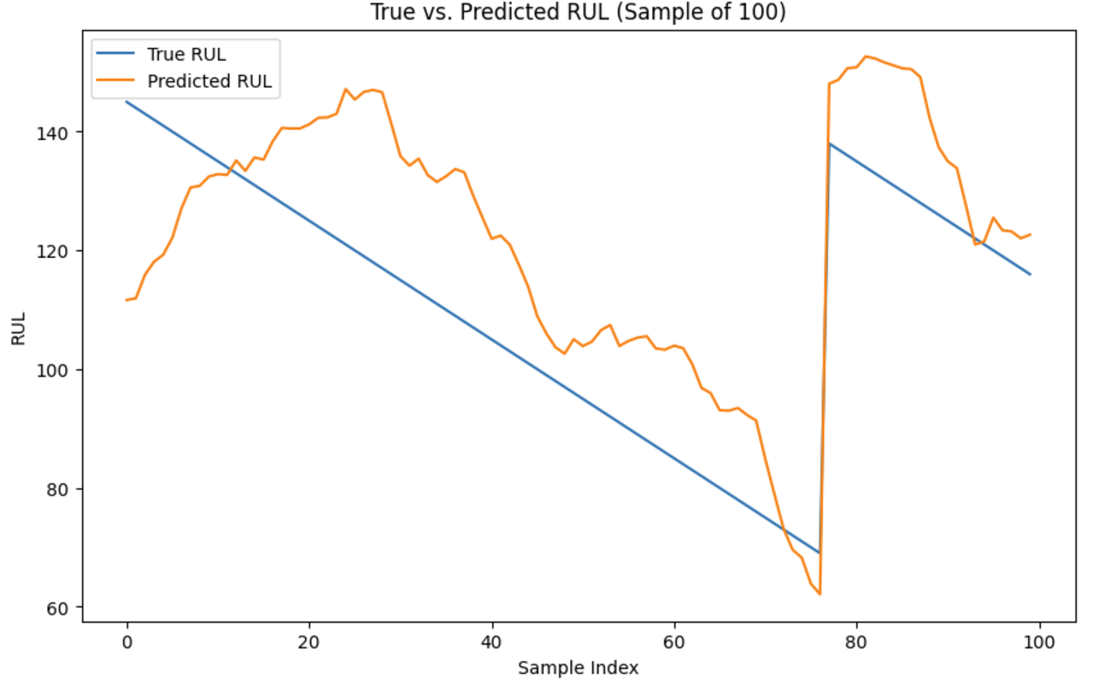

*Figure 1*

Figure 1 illustrates the model's ability to predict the RUL of turbofan engines using the NASA Turbofan Engine Degradation Simulation dataset. The blue line represents the actual RUL (ground truth), while the orange line indicates the predicted RUL generated by the LSTM model.

* **Observations**:
  + The LSTM model generally captures the downward trend in RUL, demonstrating its capacity to model temporal dependencies in engine degradation.
  + Deviations in certain segments highlight areas where the model's prediction diverges, indicating opportunities for refinement in capturing abrupt changes in degradation.
* **Significance**: The comparison highlights the effectiveness of the model in predicting RUL for maintenance planning while identifying limitations in handling sudden failure patterns.

These results validate the utility of the LSTM architecture in predictive maintenance tasks, with potential improvements possible through additional features or advanced architectures.

**Intellectual Merits**

**Advancement of Existing Literature**

This research advances the existing literature by demonstrating the effectiveness of Long Short-Term Memory (LSTM) networks in predictive maintenance for high-performance engines using real-time sensor data. Prior studies, such as Peringal, Mohiuddin, and Hassan (2024), have highlighted the superior capability of LSTM models in capturing temporal dependencies in engine degradation, achieving accurate predictions of Remaining Useful Life (RUL) for aircraft engines. Their work validates the applicability of LSTMs to real-world scenarios, emphasizing the utility of deep learning in addressing complex time-series challenges.

Furthermore, Lai et al. (2022) extended the potential of LSTM-based models by integrating Multi-Dimensional Self Attention mechanisms, enhancing both the performance and interpretability of RUL estimation models. This innovation underscores the importance of incorporating advanced architectural features to refine predictive maintenance tasks and improve stakeholder trust through better model transparency.

By building on these advancements, this study not only validates the use of LSTM networks for predictive maintenance but also contributes to machine learning by exploring interpretability methods tailored for complex time-series data. These findings push the boundaries of deep learning applications in dynamic environments, further solidifying the role of LSTM networks in predictive analytics for high-performance engines.

**Inspiring Future Research Directions**

The study's findings open avenues for future research, such as:

* Exploring Advanced Models: Investigating the use of transformers or hybrid models for time-series prediction in maintenance applications (Zhao et al. 2023).
* Integrating Additional Data Sources: Incorporating operational settings or environmental data to enhance model predictions.
* Applying to Other Industries: Adapting the framework to other domains like manufacturing or energy sectors to validate its generalizability.

**Practical Impacts**

**Societal and Real-World Benefits**

The findings have significant implications for improving engine reliability, reducing maintenance costs, and enhancing operational efficiency in the aerospace industry. Predictive maintenance models can prevent unexpected engine failures, optimize maintenance schedules, and improve safety for passengers and crew.

**Potential Applications**

* Aerospace Industry: Airlines and maintenance organizations can implement these models to predict engine failures and schedule maintenance proactively, reducing downtime and improving fleet reliability.
* Manufacturing of Engines: Manufacturers can use predictive models to improve design and testing processes, enhancing product quality.

**AI Governance and Ethical Considerations**

* Governance Challenges: Deploying these models requires addressing data privacy and security concerns, especially when handling sensitive operational data.
* Ethical Issues: Ensuring that models do not introduce biases that could overlook certain failure modes or operational conditions.
* Fairness and Accountability: Transparency in model decisions through interpretability tools is crucial for accountability and building trust among stakeholders.

**Appendix - Additional Methods**

**Explanation**

Model-agnostic interpretability tools like LIME (Local Interpretable Model-Agnostic Explanations) are explored to approximate the model locally and explain individual predictions. However, due to the high dimensionality and sequential nature of the data, these methods are adapted accordingly.

Data visualization techniques are employed extensively:

* Time-Series Plots: Visualizing sensor readings over time to detect trends, cycles, and anomalies.
* Correlation Heatmaps: Exploring relationships between different sensors to identify potential multicollinearity or redundant features.
* Anomaly Detection Visuals: Highlighting periods where sensor readings deviate significantly from normal patterns, indicating potential failures.

**Causal Inference**

Exploring causal relationships within the data can provide valuable insights into maintenance needs:

* Granger Causality Tests: Determining if one time series can predict another, suggesting potential causal links between sensor readings and engine degradation.
* Vector AutoRegression (VAR): Modeling the linear interdependencies among multiple time series.
* Transfer Entropy: Measuring the information transfer between variables to identify directional relationships.

**Optimization**

Optimization strategies focus on enhancing model performance and efficiency:

* Hyperparameter Tuning: Using methods like Bayesian optimization to efficiently explore the hyperparameter space.

**Supplementary Materials**

GitHub URL: <https://github.com/STATS201-DKU-Autumn2024/Final_Project_Tangxu/tree/main>

**References**

Hochreiter, Sepp, and Jürgen Schmidhuber. "Long Short-Term Memory." *Neural Computation* 9, no. 8 (1997): 1735–1780. <https://dl.acm.org/doi/10.1162/neco.1997.9.8.1735>.

Lai, Zhi, Mengjuan Liu, Yunzhu Pan, and Dajiang Chen. 2022. "Multi-Dimensional Self Attention-Based Approach for Remaining Useful Life Estimation." *arXiv*. December 12, 2022. <https://arxiv.org/abs/2212.05772>.

Lundberg, Scott M., and Su-In Lee. "A Unified Approach to Interpreting Model Predictions." In *Advances in Neural Information Processing Systems* 30 (2017): 4765–4774. <https://arxiv.org/abs/1705.07874>.

Peringal, Anees, Mohammed Basheer Mohiuddin, and Ahmed Hassan. 2024. "Remaining Useful Life Prediction for Aircraft Engines Using LSTM." *arXiv*. January 15, 2024. <https://arxiv.org/abs/2401.07590>.

Saxena, A., and Goebel, K. 2008. "Turbofan Engine Degradation Simulation Data Set." NASA Prognostics Data Repository, NASA Ames Research Center, Moffett Field, CA. <https://data.nasa.gov/Aeorspace/CMAPSS-Jet-Engine-Simulated-Data/ff5v-kuh6>.

Zhao, Y., et al. "TranDRL: A Transformer-Driven Deep Reinforcement Learning Enabled Prescriptive Maintenance Framework." arXiv preprint arXiv:2309.16935 (2023). <https://arxiv.org/abs/2309.16935>.